THEORY QUESTIONS

PART I

MAP SKILLS AND THE ENVIRONMENT
1.
Use the map below to answer the following questions
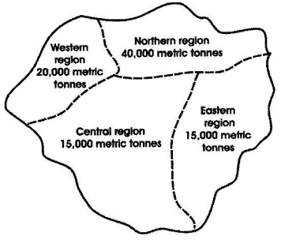
(a)

Draw the bar graph to represent the consumption of fertilizer by the four regions of Chero.
(b)

Calculate the total volume of fertilizers used in Chero as shown on the map.
(c)

Which two regions used the least amount of fertilizer in Chero?

2.
(a)

Name the three (3) types of rainfall.
(b)

With the aid of a diagram, describe how any one type of rainfall is formed.

PART II

NATIONAL COMMUNITY
3.
(a)

Mention four types of agricultural practices in Ghana.
(b)

Give two advantages and two disadvantages each of any two of the types of agricultural practices mentioned in (a) above.

4.
Explain the importance of a named festival of one tribe in Ghana.

PART III

WEST AFRICA, AFRICA AND THE WORLD
5.
(a)

What are the four major problems related to cattle rearing in Africa.
(b)

Suggest solutions to any two of these problems.

6.
(a)

State five aims of the Organization of African Unity (O.A.U).
(b)

Mention five achievements of the Organization of African Unity (O.A.U).

